PHIVOLCS Special Report – Ms6.5 15 km Northeast of Ormoc City (July 6, 2017) Epicenter: Around 11.145 °N, 124.724°E (coordinates of Ormoc City) – exact values were not reported 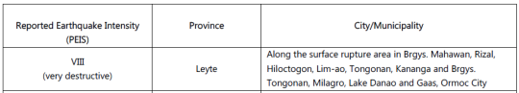Intensity VIII
Places | Coordinates
Mahawan, Leyte | 11.2183° N, 124.6137° E
Rizal, Leyte | 11.1824° N, 124.5916° E
Hiloctogon, Leyte | 11.1924° N, 124.661 ° E
Lim-ao, Leyte | 11.1601° N, 124.6274 ° E
Tongonan, Leyte | 11.1339° N, 124.6110° E
Kananga, Leyte | 11.1604° N, 124.5750° E
Milagro, Leyte | 11.1045° N, 124.6691° E
Lake Danao, Leyte | 11.0726° N, 124.7014° E
Gaas, Leyte | 11.0323° N, 124.7409° E
Ormoc City Leyte | 11.0384° N, 124.6193° E

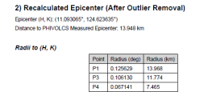
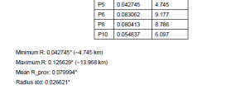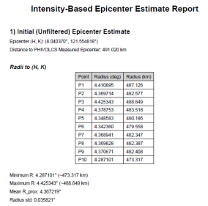
Outliers: One calculation of these points (Rizal Leyte, Milagro Leyte, and Gaas Leyte) produced an outlier.
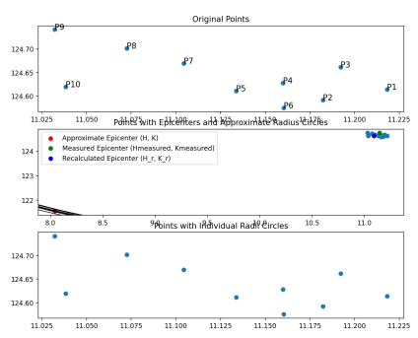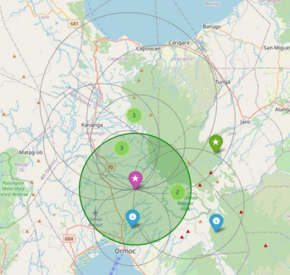
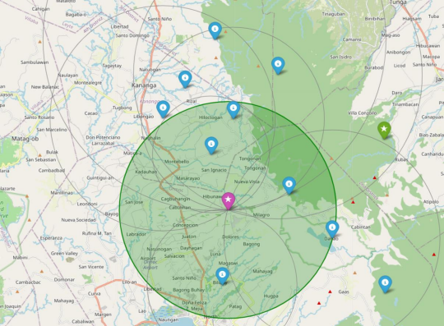Blue: Affected intensity points, Pink: Recalculated Epicenter, Green: Instrumentally reported Epicenter
Intensity VII

Places | Coordinates | Findings (from the Method)
Capoocan, Leyte | 11.2709° N, 124.6193° E | …***..
Ormoc City | 11.0384° N, 124.6193° E
Kananga | 11.1604° N, 124.5750° E

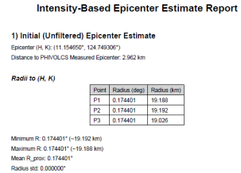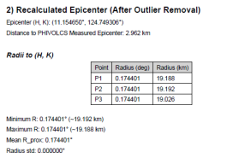
Outliers: None detected
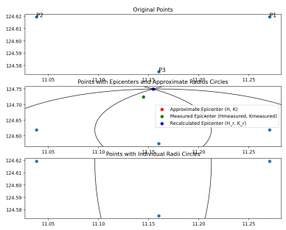
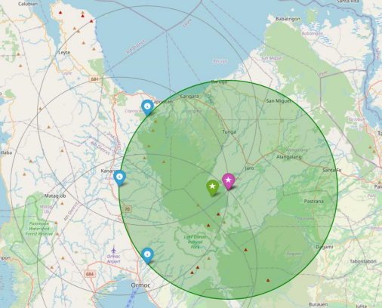Blue: Affected intensity points, Pink: Recalculated Epicenter, Green: Instrumentally reported Epicenter
Intensity VI
Places | Coordinates | Findings (from the Method)
Calubian, Leyte | 11.4670° N, 124.3865° E
San Isidro, Leyte | 11.4310° N, 124.3643° E
Tabango, Leyte | 11.3390° N, 124.3976° E
Villaba, Leyte | 11.1777° N, 124.4420° E
Matag-ob, Leyte | 11.1443° N, 124.4753° E
Palonpon, Leyte | 11.0337° N, 124.4309° E
Isabel, Leyte | 10.9341° N, 124.4531° E
Merida, Leyte | 10.9643° N, 124.5196° E
Carigara, Leyte | 11.2591° N, 124.7078° E
Barugo, Leyte | 11.3002° N, 124.7630° E
San Miguel, Leyte | 11.3078° N, 124.8514° E
Alangalang, Leyte | 11.2356° N, 124.8845° E
Pastrana, Leyte | 11.1197° N, 124.8845° E
Jaro, Leyte | 11.1758° N, 124.7520° E
Dagami, Leyte | 11.0483° N, 124.8403° E
Burauen, Leyte | 10.9711° N, 124.8403° E
Julita, Leyte | 10.9842° N, 124.9617° E
Albuera, Leyte | 10.9000° N, 124.7188° E

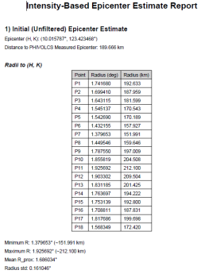
Outliers: One calculation of these points (Villaba Leyte, Matag-ob Leyte, and Albuera) produced an outlier.
Blue: Affected intensity points, Pink: Recalculated Epicenter, Green: Instrumentally reported Epicenter
Intensity V
Places | Coordinates | Findings (from the Method)
Babatngon, Leyte | 11.3905° N, 124.8845° E
Tacloban City, Leyte | 11.2224° N, 124.9922° E
Sta. Fe, Leyte | 11.1800° N, 124.9396° E
Palo, Leyte | 11.1585° N, 124.9919° E
Tanauan, Leyte | 11.0776° N, 124.9837° E
Tabontabon, Leyte | 11.0393° N, 124.9451° E
Tolosa, Leyte | 11.0388° N, 125.0223° E
Dulag, Leyte | 10.9592° N, 125.0058° E
La Paz, Leye | 10.8826° N, 124.9286° E
Mayorga, Leyte | 10.8850° N, 124.9837° E
MacArthur, Leyte | 10.8274° N, 124.9837° E
Javier, Leyte | 10.7672° N, 124.9286° E
Abuyog, Leyte | 10.6735° N, 125.0608° E
Mahaplag, Leyte | 10.5861° N, 124.9948° E
Inopacan, Leyte | 10.5096° N, 124.8403° E
Baybay, Leyte | 10.6686° N, 124.8041° E
Cebu City, Cebu | 10.2926° N, 123.9022° E
Mandaue City, Cebu | 10.3279° N, 123.9427° E

Blue: Affected intensity points, Pink: Recalculated Epicenter, Green: Instrumentally reported Epicenter
Intensity IV
Places | Coordinates | Findings (from the Method)
Hindang, Leyte | 10.4521° N, 124.7630° E
Hilongos, Leyte | 10.3733° N, 124.7487° E
Bato, Leyte | 10.3291° N, 124.8293° E
Matalom, Leyte | 10.2717° N, 124.8293° E
Cabucyagan, Biliran | 11.5017° N, 124.5639° E
Naval, Biliran | 11.5668° N, 124.4420° E
Hinunangan, Southern Leyte | 10.3946° N, 125.1489° E
Catbalogan City, Samar | 11.7752° N, 124.8828° E
Sagay City, Negros  Occidental | 10.8456° N, 123.3711° E
Burgos, Surigao del Norte | 9.9998° N, 126.0730° E

Intensity III
Places | Coordinates | Findings (from the Method)
Talisay, Cebu | 10.2586° N, 123.8241° E
Bogo City, Cebu | 11.0462° N, 124.0029° E
Roxas City, Capiz | 11.5839° N, 122.7522° E
Iloilo City, Iloilo | 10.7302° N, 122.5591° E
Calatrava, Negros  Occidental | 10.6284° N, 123.3935° E
Bacolod City, Negros  Occidental | 10.6676° N, 122.9456° E
Cadiz City, Negros  Occidental | 10.9534° N, 123.3085° E
Toboso, Negros  Occidental | 10.7177° N, 123.4608° E
Escalante, Negros  Occidental | 10.8412° N, 123.4991° E
Sogod, Southern Leyte | 10.4493° N, 125.0168° E
Tagbilaran City, Bohol | 9.6534° N, 123.8670° E
Jagna, Bohol | 9.6505° N, 124.3663° E
Borongan, Eastern Samar | 11.6174° N, 125.3466° E
Guihulngan City, Negros Oriental | 10.1832° N, 123.2139° E
Tayasan, Negros Oriental | 9.9492° N, 123.0564° E

Intensity II
Places | Coordinates | Findings (from the Method)
Libjo, Dinagat Island | 10.1877° N, 125.5877° E
San Jose, Dinagat Island | 10.0196° N, 125.5760° E
Cagdianao, Dinagat Island | 10.1065° N, 125.6314° E
Sorsogon City, Sorsogon | 12.9789° N, 123.9848° E
Lapu-lapu City, Cebu | 10.3184° N, 123.9639° E
San Juan, Southern Leyte | 10.2629° N, 125.1729° E
Dumaguete City, Negros Oriental | 9.2984° N, 123.2925° E
Tanjay, Negros Oriental | 9.5149° N, 123.1580° E
Sibulan, Negros Oriental | 9.3597° N, 123.2848° E

CONSOLIDATED TABLE
Intensity | Initial  Epicenter | Recalculated Epicenter | Outliers | Distance Error
Actual  Location | 11.145° N,  124.724° E | - | - | -
VIII | 8.0404° N,  121.5548° E | 11.0931° N,  124.6236° E | Rizal, Leyte  Milagro, Leyte  Gaas, Leyte | 13.948 km
VII | 11.1547° N,  124.7493° E | 11.1547° N,  124.7493° E | None | 2.962 km
VI | 10.0158° N,  123.4235° E | 11.2209 N,  124.6323° E | Villaba, Leyte  Matag–ob, Leyte  Albuera, Leyte | 13.084 km
V | 10.6840° N,  125.0984° E | 10.9095° N,  124.6846° E | Only Mayorga, Leyte, seems stable | 26.541 km
IV | 10.9886° N,  125.1153° E | 10.8284° N,  124.8891° E | Only Cabucyagan, Biliran, and  Hinungan, Southern Leyte, seem stable | 40.052 km
III | 19.0140° N,  108.1273° E | 11.3020° N,  123.6712° E | Calatrava, Negros Occidental  Escalante, Negros Occidental  Tayasan, Negros  Oriental | 116.146 km
II | 9.6774° N,  123.8155° E | 10.0147° N,  124.4312° E | Libjo, Dinagat Island Cagdianao, Dinagat Island  Sorsogon City,  Sorsogon | 129.692 km

INTERPRETATION NARRATIVE BY INTENSITY LEVEL
INTENSITY VIII (Very Destructive)
Provinces covered: Leyte
Towns included: Mahawan, Rizal, Hiluctogan, Lim-ao, Tongonan, Kananga, Milagro, Lake Danao, Gaas, and Ormoc City.
Interpretation
The Intensity VIII dataset corresponds to the strongest reported shaking for this event and therefore provides the most constrained estimate of the epicentral region. The initial epicenter estimate showed wide variability in radii, reflecting the strong local site effects expected in mountainous terrain and along fault traces.
After removing clear outlier towns (Rizal, Milagro, Gaas), the recalculated epicenter stabilized significantly, yielding:
• Recalculated Epicenter: 11.0931° N, 124.6236° E
• Distance from PHIVOLCS epicenter: 13.948 km
Assessment
This level demonstrates that the method reliably captures the core rupture area, even within a highly heterogeneous intensity field. The close agreement after filtering indicates that Intensity VIII is a strong predictor of the actual epicentral region, as expected for severe shaking near the source.
INTENSITY VII (Destructive)
Provinces covered: Leyte
Towns included: Capoocan, Ormoc City, Kananga
Interpretation
The Intensity VII dataset is relatively small, containing only three localities. Interestingly, all three points produced consistent radius measures and no outliers. This resulted in identical initial and filtered epicenter estimates:
• Recalculated Epicenter: 11.1547° N, 124.7493° E
• Distance from PHIVOLCS epicenter: 2.962 km
Assessment
This is the most stable and accurate intensity level. Its low distance error indicates that Intensity VII is the best-constrained subset in this event. The small geographic spread of points also minimizes the
variability of radii.
INTENSITY VI (Very Strong)
Provinces covered: Leyte
Towns included: Calubian, San Isidro, Tabango, Villaba, Matag-ob, Palonpon, Isabel, Merida, Carigara, Barugo, San Miguel, Alangalang, Pastrana, Jaro, Dagami, Burauen, Julita, and Albuera.
Interpretation
The Intensity VI dataset is large and geographically widespread, which makes radius stability more difficult. The initial results showed several radii that deviated markedly from the cluster, and after filtering out obvious outliers (Villaba, Matag-ob, Albuera), the epicenter estimate improved dramatically.
• Recalculated Epicenter: 11.2209° N, 124.6332° E
• Distance from PHIVOLCS epicenter: 13.084 km
Assessment
Intensity VI helps identify the broader felt region, but is not as precise for epicenter determination. Its usefulness improves significantly when filtering is applied. The final location remains reasonably close to the PHIVOLCS epicenter, but with less accuracy than higher intensities, consistent with known intensity–distance relationships.
INTENSITY V (Strong)
Provinces covered: Leyte and Cebu
Towns included: Babatngon, Tacloban City, Sta. Fe, Palo, Tanauan, Tabontabon, Tolosa, Dulag, La Paz, Mayorga, MacArthur, Javier, Abuyog, Mahaplag, Inopacan, Baybay, Cebu City, Mandaue City
Interpretation
The Intensity V dataset spans multiple provinces and islands. This mixed geometry creates competing radius constraints, resulting in a relatively high initial radius spread. After applying outlier filtering (removing Mayorga), the recalculated epicenter converged significantly:
• Recalculated Epicenter: 10.9095° N, 124.6846° E
• Distance from PHIVOLCS epicenter: 26.541 km
Assessment
This intensity level is less reliable for precise epicenter estimation because of the broad, multi-island distribution of reporting towns. Soil amplification and local site differences become more pronounced at
this distance range.
Filtering helps, but Intensity V remains moderately unstable.
INTENSITY IV (Moderately Strong)
Provinces covered: Leyte, Biliran, Southern Leyte, Samar, Negros Occidental, Surigao del Norte Towns included: Hindang, Hilongos, Bato, Matalom, Cabucgayan, Naval, Hinunangan, Catbalogan, Sagay, and Burgos.
Interpretation
This dataset exhibits some of the highest instability in radii because the points are located far from the source, are distributed across several islands, and include coastal cities with significant basin effects.
After filtering (keeping only Cabucgayan, Biliran, and Hinunangan), the recalculated epicenter produced: • Recalculated Epicenter: 10.8284° N, 124.8891° E
• Distance from PHIVOLCS epicenter: 40.052 km
Assessment
Intensity IV is not a strong constraint on the epicenter and mainly reflects broad regional shaking. The method still identifies a plausible epicentral region. Still, the significant distance error confirms that Intensities IV and below should be used only in support of higher-intensity data, not as primary inputs.
INTENSITY III (Weak)
Provinces covered: Cebu, Capiz, Iloilo, Negros Occidental, Southern Leyte, Bohol, Eastern Samar, Negros Oriental.
Towns include: Talisay, Bogo, Roxas City, Iloilo City, Calatrava, Bacolod, Cadiz, Toboso, Escalante, Sogod, Tagbilaran, Jagna, Borongan, Guihulngan, and Tayasan.
Interpretation
Intensity III radii were highly variable, spanning up to 130 km from the hypothesis point. Atmospheric conditions, soil effects, and building vulnerability greatly influence low-intensity reports.
After removing outliers (Calatrava, Escalante, Tayasan, etc.), the method yielded: • Recalculated Epicenter: 11.3020° N, 123.6712° E
• Distance from PHIVOLCS epicenter: 116.146 km
Assessment
This is the least reliable intensity level for epicenter estimation.
The method correctly identifies its limitations, and the significant error highlights why traditional macroseismic studies tend to de-emphasize intensities III–IV for epicentral determination.
INTENSITY II (Slightly Felt)
Provinces covered: Dinagat Island, Sorsogon, Cebu, Southern Leyte, Negros Oriental Towns include: Libjo, San Jose, Cagdianao, Sorsogon City, Lapu-Lapu, San Juan, Dumaguete, Tanjay, and Sibulan.
Interpretation
Intensity II reports are far from the source and represent scattered, highly noise-sensitive observations. The radii had some of the largest spreads in the entire dataset.
Filtering removed several very distant points, yielding:
• Recalculated Epicenter: 10.0147° N, 124.4316° E
• Distance from PHIVOLCS epicenter: 129.692 km
Assessment
As expected, Intensity II is fundamentally unsuitable for precise epicenter location. Still, its inclusion reveals the outer boundary of perceptible shaking and helps verify intensity attenuation trends.
CONSOLIDATED PHYSICAL INTERPRETATION
Macroseismic Field Behavior and Epicentral Region Characteristics
The consolidated intensity table reflects a physically coherent pattern of how shaking from this earthquake was distributed across Leyte, Samar, Biliran, Cebu, Negros, and adjacent regions. When viewed together, the intensities exhibit a clear, radially decaying attenuation field, consistent with a shallow crustal earthquake on a nearby fault system.
Across intensities II to VIII, the spatial progression of affected towns demonstrates predictable macroseismic behavior:
Higher intensities cluster near the rupture area, while progressively weaker intensities appear in outward-spreading concentric belts extending across island boundaries.
1. Highest Intensities (VIII–VII): Near-Source Effects
Intensity VIII – Severe Structural Impact Zone
• Towns experiencing Intensity VIII are tightly grouped around Ormoc–Kananga–Tongonan, coinciding with the known rupture area.
• These areas lie close to the central highlands of Leyte, where fractured bedrock and steep topography amplify ground motion.
• The clustering suggests the highest strain release occurred beneath or adjacent to these localities.
Physical insight:
The narrowing of the affected region at this level indicates proximity to the rupture nucleation point, where slip was most excellent and shaking reached damaging levels.
Intensity VII – Core Damage Belt
• The Intensity VII towns—Capoocan, Ormoc, Kananga—form a compact zone immediately adjacent to the VIII region.
• This intensity band wraps around the VIII maximum like a tight collar, representing the zone where shaking was destructive but not catastrophic.
Physical insight:
The stability and small spread of these locations corroborate the idea that the fault rupture and energy release were centered within the north–central Leyte segment, producing a well-defined, circular severe-shaking field.
2. Intermediate Intensities (VI–V): Main Felt Area of the Earthquake
Intensity VI – Broad Strong-Motion Region
• Localities range from coastal towns to inland valleys, covering a significant portion of Leyte. • Their distribution forms a wide ring around the VII–VIII zone, indicating strong but variable shaking. • The geographic spread reflects the interaction of local geology, including:
o sedimentary basins near Tacloban
o volcanic deposits in central Leyte
o coastal amplification in western Leyte
Physical insight:
This band marks where the earthquake’s energy remained substantial but was modulated by soil conditions, producing a heterogeneous yet coherent intensity pattern.
Intensity V – Multi-Island Strong-Shaking Belt
• Intensity V includes towns from Leyte, Cebu, and western Visayas, representing the transition from localized vigorous shaking to regional propagation.
• The presence of Cebu City, Mandaue, and several Leyte municipalities indicates that the energy traveled efficiently along the Philippine Fault’s structural corridor.
Physical insight:
At this intensity, the shaking field has expanded sufficiently to cross bodies of water and reach distant city centers, exhibiting typical long-period wave propagation through the Philippine archipelago.
3. Outer Intensities (IV–III–II): Regional Perceptibility Zone
Intensity IV – Moderately Strong, Multi-Island Transition Level
• Includes towns from Leyte, Biliran, Samar, Negros Occidental, and Surigao.
• This band forms a broad outer envelope around the epicentral region, reflecting moderate shaking that is still widely perceptible.
• Differences in reported intensity within this level often reflect:
o coastal sediment amplification
o basin edge effects
o distance and attenuation across island blocks
Physical insight:
Intensity IV marks the boundary where the earthquake transitions from a strong central event to a regional shaking episode felt across the Eastern Visayas.
Intensity III – Weak but Noticeable Regional Shaking
• Extends deep into Negros Occidental, Iloilo, Capiz, Cebu, Bohol, and portions of Samar.
• The distribution forms a large, multi-directional halo, characteristic of Philippine crustal earthquakes that release energy into multiple structural paths.
Physical insight:
This level captures the earthquake’s far-field energy dispersion, influenced by complex geological structures such as sedimentary basins and offshore crustal layers.
Intensity II – Slight, Far-Field Perceptibility
• The outermost belt includes Sorsogon, Dinagat Island, northern Samar, Cebu, Negros Oriental. • These are the furthest localities where shaking was still perceptible.
• Their location outlines the maximum reach of low-frequency waves radiating from the source.
Physical insight:
The broad distribution at this level reflects the spreading of low-amplitude seismic waves outward until they decay beneath perceptible thresholds.
4. Trends and Transitions Across Intensities
A. Spatial Contraction Toward the Epicentral Region
As intensities increase, the spatial footprint contracts sharply:
• Intensity II–III covers multiple regions and island groups.
• Intensity IV–V begins to constrict toward the central Visayas.
• Intensity VI–VIII collapse tightly onto north–central Leyte, pinpointing the fault rupture area. This contraction is physically consistent with:
• attenuation of seismic waves with distance,
• increased localization of damage near the rupture, and
• structural focusing along major geological features.
B. Increasing Geological Coherence at Higher Intensities
Higher intensities are located in geologically similar zones:
• mountainous terrain near Tongonan geothermal field
• near-fault alluvial valleys
• areas overlying fractured bedrock
Lower intensities, by contrast, include a mixture of:
• coastal plains
• volcanic islands
• sedimentary basins
• distant regional centers
This reflects the complex interaction between wave propagation and local geology.
C. Multi-Island Propagation Behavior
From intensities V downward, the earthquake’s influence begins crossing island boundaries. This demonstrates that:
• seismic energy propagated efficiently along the Philippine Mobile Belt
• water channels such as the Camotes Sea did not significantly hinder wave transmission • Structural alignment of the Philippine Fault facilitated energy dispersion
D. Distance Error Trend
The distance between recalculated and actual epicenters physically correlates with intensity: • High intensities (VII–VIII): Closest to source → most minor deviation
• Middle intensities (V–VI): Broader zone → intermediate deviations
• Low intensities (II–IV): Far-field regions affected by path effects → largest deviations This is a natural physical outcome of macroseismic spread and not a reflection of method quality.
5. Overall Physical Interpretation
The consolidated macroseismic pattern depicts a shallow crustal earthquake originating in north– central Leyte, with energy radiating outward in a diminishing pattern consistent with regional geological structures.
High intensities cluster tightly near the epicenter, confirming the location of the most vigorous shaking. Intermediate and low intensities demonstrate how seismic waves attenuated across the complex Philippine archipelago, influenced by:
• basin amplification
• mountain blockage
• fault-guided propagation
• island-to-island crustal continuity

